NATIONAL FEDERATION OF STATE
HIGH SCHOOL ASSOCIATIONS
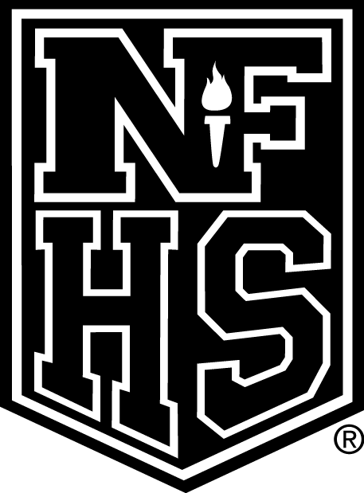

NEWS RELEASE

New Rules Regarding Electronic Devices Approved in High School Softball
FOR IMMEDIATE RELEASE Contact: Theresia Wynns
INDIANAPOLIS, IN (November 8, 2026) — Two new rules regarding the use of electronic devices in high school softball were among the five changes approved by the National Federation of State High School Associations (NFHS) Softball Rules Committee at its June 10-12 meeting in Indianapolis. All rules changes were subsequently approved by the NFHS Board of Directors.
With the addition of Rule 1-8-6, team personnel are permitted to use electronic devices to transmit or record information pertaining to their players or team’s performances. This is to be done only in the team’s bench or dugout areas, and the information obtained may be used for coaching purposes during the game.
“The committee felt that with the advancement of technology, it was time to allow electronic devices to be used,” said Theresia Wynns, NFHS director of sports and officials education and staff liaison for softball. “It focused on what was good for softball and that the devices could be a useful tool to aid in coaching.”
According to Rule 3-6-11, information obtained by electronic devices shall not be used to review decisions made by the umpires.
Wynns said that the committee strongly opposed the use of information obtained by the electronic devices to dispute an umpire about a specific call on the field.
“The committee did not want to give teams a competitive advantage,” she said. “It also did not want to hamper the progress of the game.”
In other changes, the committee established definitions for “team members” and “team personnel.”
Team members are players listed on the team’s roster and lineup as submitted to the umpire at the pregame meeting. Team personnel consist of all school representatives located in the team dugout, including but not limited to coaches, managers, certified athletic trainers and scorekeepers.
The committee also revised Rule 1-5-2c by eliminating “smooth” from the description of the taper, noting that not all bats have smooth tapers.
Fast-pitch softball is the fifth-most popular sport for girls at the high school level, according to the 2011-12 NFHS Athletics Participation Survey, with 367,023 participants nationwide. The sport ranks fourth in school sponsorship with 14,142 schools offering the sport.

This press release was written by Jason Haddix, a 2013 spring/summer intern in the NFHS Publications/Communications Department. He is a senior at Indiana University-Purdue University Indianapolis studying journalism and medical imaging.

###
About the National Federation of State High School Associations (NFHS)
The NFHS, based in Indianapolis, Indiana, is the national leadership organization for high school sports and performing arts activities. Since 1920, the NFHS has led the development of education-based interscholastic sports and performing arts activities that help students succeed in their lives. The NFHS sets direction for the future by building awareness and support, improving the participation experience, establishing consistent standards and rules for competition, and helping those who oversee high school sports and activities. The NFHS writes playing rules for 17 sports for boys and girls at the high school level. Through its 50 member state associations and the District of Columbia, the NFHS reaches more than 19,000 high schools and 11 million participants in high school activity programs, including more than 7.6 million in high school sports. As the recognized national authority on interscholastic activity programs, the NFHS conducts national meetings; sanctions interstate events; offers online publications and services for high school coaches and officials; sponsors professional organizations for high school coaches, officials, speech and debate coaches, and music adjudicators; serves as the national source for interscholastic coach training; and serves as a national information resource of interscholastic athletics and activities. For more information, visit the NFHS Web site at www.nfhs.org.

MEDIA CONTACTS: Bruce Howard, 317-972-6900
National Federation of State High School Associations
PO Box 690, Indianapolis, Indiana 46206
bhoward@nfhs.org

